35. Scatter Plot Comparing Two Subject Marks

import matplotlib.pyplot as plt
maths = [85, 70, 90, 65, 80, 75, 95, 60]
science = [80, 75, 85, 70, 78, 80, 92, 65]
plt.scatter(maths, science)
plt.xlabel('Mathematics Marks')
plt.ylabel('Science Marks')
plt.title('Comparison of Mathematics and Science Marks')
plt.show()

OUTPUT:
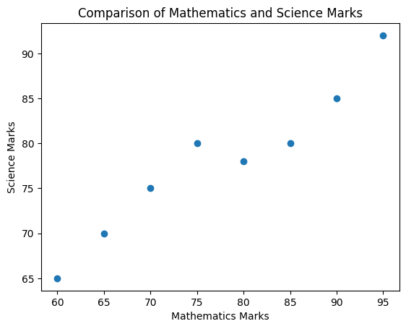

36. Scatter Plot for Three Groups Comparing Weight and Height

import matplotlib.pyplot as plt
weight1 = [45, 50, 55, 60, 65]
height1 = [150, 155, 160, 165, 170]
weight2 = [50, 55, 60, 65, 70]
height2 = [155, 160, 165, 170, 175]
weight3 = [55, 60, 65, 70, 75]
height3 = [160, 165, 170, 175, 180]
plt.scatter(weight1, height1, label='Group 1')
plt.scatter(weight2, height2, label='Group 2')
plt.scatter(weight3, height3, label='Group 3')
plt.xlabel('Weight (kg)')
plt.ylabel('Height (cm)')
plt.title('Weight vs Height for Three Groups')
plt.legend()
plt.show()
OUTPUT:
